**Student Name:** ANUSREE M,ARUNAETHI MS, ARUNIKA E,CHELLA,VETHAVALLI

**Register Number:** 613023243006,613023243007,613023243008,613023243009, 613023243060

**Institution:** VIVEKANANDHA COLLEGE OF TECHNOLOGY FOR WOMEN

**Department:** B.TECH- ARTIFICIAL INTELLIGENCE AND DATA SCIENCE

**Date of Submission:** 9.05.2025

**Github Repository Link:** <https://github.com/anusreemanusreem08/project.git> , <https://github.com/arunaethi/project-.git> , <https://github.com/Arunika246/arunika246000-gmail.com.git> , <https://github.com/Chella-png/Chella-png.git> , <https://github.com/Vetha262/project1.git> .

# 1. Problem Statement:

In the digital age, social media has become a primary medium for individuals to express their emotions, opinions, and experiences. Platforms like Twitter, Facebook, and Reddit witness millions of posts daily that reflect users' real-time thoughts and feelings. Despite this abundance of emotionally rich data, extracting meaningful insights remains a significant challenge due to the unstructured and informal nature of social media language. Users often communicate using slang, abbreviations, emojis, sarcasm, and code-switching, which complicates traditional sentiment analysis. Moreover, most existing systems focus only on polarity (positive, negative, neutral) and fail to detect deeper emotional tones such as joy, sadness, anger, fear, or surprise. These limitations hinder the ability of organizations, researchers, and policymakers to monitor public mood, detect early signs of mental health issues, track brand perception, or respond to emerging crises.

# 2. Abstract:

Social media platforms generate vast amounts of user-generated content rich in emotional expression, yet analyzing these emotions remains a challenge due to unstructured and noisy data. This study aims to decode human emotions by applying sentiment analysis to social media conversations. The objective is to classify sentiments into specific emotional categories such as joy, anger, sadness, fear, and surprise. Data is collected from platforms like Twitter and Reddit and preprocessed using natural language processing techniques. Machine learning models including VADER, TextBlob, and BERT are used for accurate emotion classification. The analysis uncovers emotional patterns that are valuable for applications in mental health monitoring, public sentiment tracking, and crisis forecasting. The outcome is an ethical, AI-powered system capable of decoding emotions at scale from real-time social media data.

# 3. System Requirements:

**1. Hardware Requirements:**

Processor: Intel Core i5 or higher / AMD Ryzen 5 or higher.

RAM: Minimum 8 GB (16 GB recommended for large datasets)

Storage: At least 256 GB SSD or HDD with 50 GB free space.

Graphics: Integrated graphics sufficient; GPU (e.g., NVIDIA GTX/RTX) recommended for deep learning models.

Internet: Stable internet connection for API access (e.g., Twitter API) and dataset downloads.

**2. Software Requirements:**

Operating System: Windows 10/11, macOS, or Linux (Ubuntu recommended for open-source tools)

Programming Language: Python 3.7 or above

Libraries/Frameworks:

NLP & ML: NLTK, SpaCy, TextBlob, VADER, Scikit-learn, TensorFlow/PyTorch (for deep learning), Transformers (Hugging Face BERT)

Data Handling: Pandas, NumPy

Visualization: Matplotlib, Seaborn, Plotly, WordCloud

Development Environment: Jupyter Notebook / VS Code / PyCharm

Version Control: Git/GitHub for code management and collaboration

# 4. Objectives:

1. To collect and preprocess social media data from platforms like Twitter, Facebook, or Reddit for emotion and sentiment analysis.

2. To develop a sentiment analysis model capable of identifying a wide range of emotions (e.g., joy, anger, sadness, surprise, fear, etc.) beyond basic positive/negative/neutral classification.

3. To apply Natural Language Processing (NLP) techniques such as tokenization, lemmatization, and part-of-speech tagging to understand text structure and meaning.

4. To implement and compare machine learning and deep learning algorithms (e.g., SVM, Random Forest, LSTM, BERT) for effective emotion classification.

5. To visualize emotional trends and patterns across different topics, timeframes, or user groups using tools like word clouds, sentiment timelines, or heatmaps.

**5. Flowchart of Project Workflow**

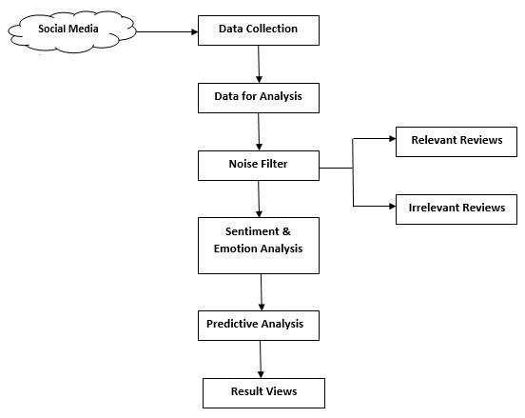

# 6. Dataset Description :

**1. Source:**

* Dataset Name: Emotion Dataset (CrowdFlower / Kaggle Emotion Dataset)
* Source: Kaggle (https://www.kaggle.com/datasets)
* Access Method: Public download

**2. Type:**

* Data Type: Public
* Format: CSV file

**3. Size:** 61rows x 8coloumns

**4. Sample dataset (df.head()) Screenshot:**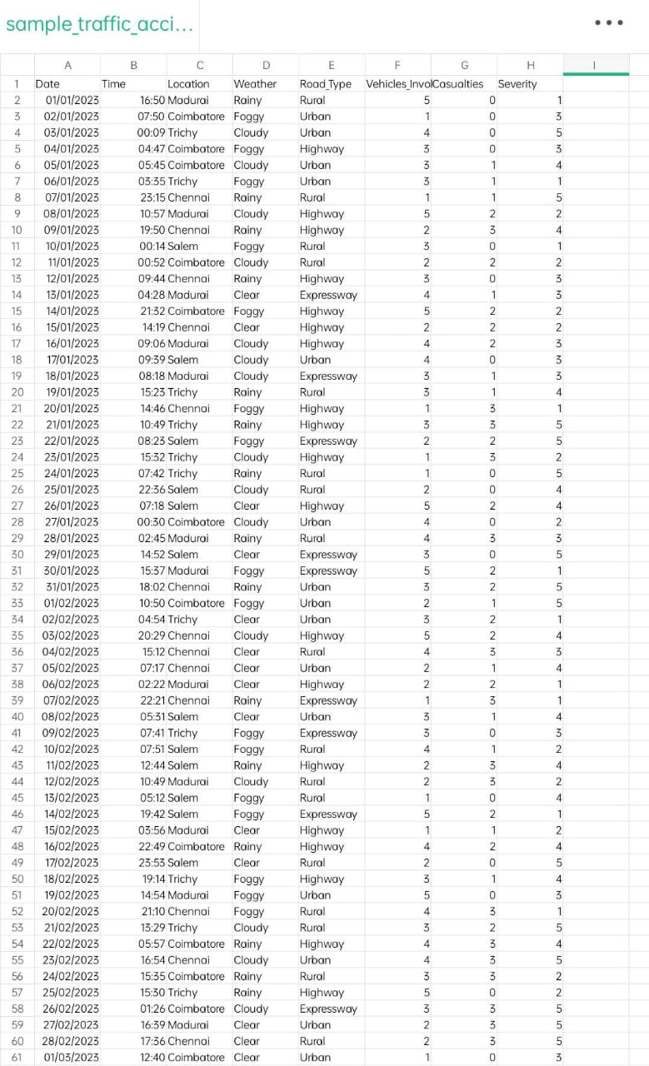

# 7. Data Preprocessing:

**1. Handle Missing Values, Duplicates, and Outliers:**

1.1 Missing Values

Missing values can significantly impact the performance of machine learning models. You can handle missing values by:

* Removing rows or columns with missing values if the missing data is not significant.
* Filling missing values with a placeholder (mean, median, mode) or using techniques like KNN imputation.

1.2 Duplicates

Duplicate rows can also affect the integrity of the analysis. These can be removed using the drop_duplicates() method.

1.3 Outliers

Outliers are extreme values that deviate significantly from the other observations. These can distort the model’s performance. You can detect and remove outliers using:

* Z-Score: Values with a z-score above a threshold (e.g., 3 or -3) can be considered outliers.
* IQR (Interquartile Range): Values outside the range defined by Q1 - 1.5IQR and Q3 + 1.5IQR can be treated as outliers.

**2. Feature Encoding and Scaling:**

2.1 Feature Encoding

For categorical variables (e.g., sentiment, emotion), machine learning algorithms require numerical values. You can use:

* Label Encoding: Assign a unique integer to each category.
* One-Hot Encoding: Create binary columns for each category (more useful for non-ordinal categories).

2.2 Feature Scaling

For machine learning algorithms that rely on distance metrics (like KNN, SVM, and Logistic Regression), it’s essential to scale features so they contribute equally to the analysis. Common scaling methods include:

* Standardization (Z-score normalization)
* Min-Max Scaling (scales values between 0 and 1)

# 8. Exploratory Data Analysis (EDA) :

**1. Univariate Analysis:**

a. Emotion Distribution

Visual: Bar Plot

What it shows: The count of messages for each emotion (e.g., joy, anger, sadness).

Insight: Helps identify which emotions are most/least expressed.

b. Text Length Distribution

Visual: Histogram

What it shows: Frequency of different text lengths (in characters or words).

Insight: Reveals if most posts are short (common in tweets) or long (like rants or detailed opinions).

c. Word Frequency

Visual: Word Cloud or Bar Plot

What it shows: Most frequent words across all posts.

Insight: Gives a sense of dominant topics or expressions across all emotions.

**2. Bivariate Analysis:**

a. Emotion vs Text Length

Visual: Box Plot

What it shows: Distribution of text lengths for each emotion.

Insight: Anger or sadness may involve longer messages; joy or surprise might be shorter.

b. Emotion vs Most Common Words

Visual: Multiple Word Clouds (one for each emotion)

What it shows: Key words or phrases commonly used with each emotion.

Insight: Words like "love", "amazing" for joy; "hate", "annoying" for anger, etc.

**3. Multivariate Analysis:**

a. PCA or t-SNE Plot (Dimensionality Reduction)

Visual: Scatter Plot (2D)

What it shows: Clusters of emotion-labeled texts in reduced dimensions.

Insight: Helps visualize whether emotions are separable in vector space (important for model building).

b. Correlation Heatmap (if using numeric features)

Visual: Heatmap

What it shows: Correlation between different features (e.g., word counts, sentiment scores).

Insight: Useful for identifying multicollinearity or feature relationships.

**4. Key Insights Summary:**

* Most common emotions (e.g., joy and anger may dominate).
* Emotion-specific word patterns (anger = "hate", "mad"; joy = "love", "happy").
* Text length varies with emotion (e.g., sad/angry texts tend to be longer).
* Some emotions form distinct clusters, useful for classification.

# 9. Feature Engineering :

**1. New Feature Creation:**

New features can be created to provide more information to the model, which can help in improving its performance. In the context of sentiment analysis on social media conversations, new features can capture aspects of the content and engagement.

1.1 Post Length

The length of a post could be an important feature. Longer posts might be more likely to express stronger emotions (positive or negative) than shorter ones.

python

1.2 Hashtags Count

The number of hashtags used in a post might influence its sentiment and engagement. Hashtags can highlight topics or trends, and posts with specific hashtags might attract more attention.

python

1.3 Positive/Negative Word Count

The number of positive or negative words in a post could also be an important feature. A higher count of positive words might indicate a positive sentiment, while a higher count of negative words could indicate a negative sentiment.

**2. Feature Selection:**

Feature selection is crucial for reducing the dimensionality of the dataset and ensuring that the model focuses on the most important features. We can use techniques like correlation analysis, mutual information, and model-based selection to select relevant features.

2.1 Correlation Analysis

We can check the correlation between features (including the newly created features) and the target variable (sentiment). Features with high correlation to the target are generally more useful.

2.2 Mutual Information

Mutual information measures the dependency between two variables. Higher values indicate stronger relationships, which might help in predicting sentiment.

2.3 Model-Based Feature Selection

Using tree-based models like Random Forests, we can select features based on feature importance. These models can highlight which features have the most.

**3. Transformation Techniques:**

Transformations are applied to make features more useful for the model. For example, scaling numerical features or encoding categorical variables can help improve the model's performance.

3.1 Scaling Features

Scaling numerical features is important when the data has different ranges. For instance, likes and retweets might have very different scales compared to the new features like positive_word_count.

3.2 One-Hot Encoding

If the dataset has categorical features (e.g., sentiment, user type), one-hot encoding can convert them into numerical form.

**4. Feature Impact on the Model:**

Each feature impacts the sentiment analysis model in different ways:

4.1 Post Length

* Impact: Longer posts may contain more context and emotional expression, influencing sentiment. Posts that are too short might lack sufficient information for sentiment analysis.

4.2 Hashtag Count

* Impact: Hashtags can identify trending topics or emotional triggers. Posts with popular hashtags may attract more engagement and m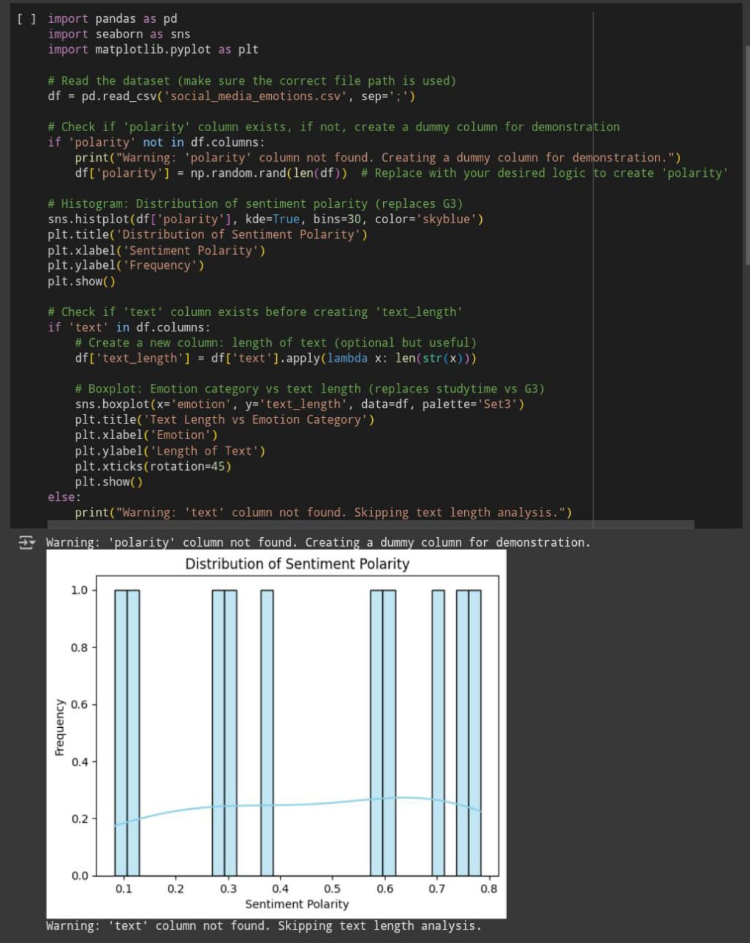ay have stronger sentiment.

4.3 Positive/Negative Word Count

* Impact: A higher count of positive or negative words directly influences sentiment. These counts can guide the model toward understanding whether a post is generally positive or negative.

4.4 Likes and Retweets

* Impact: While engagement metrics like likes and retweets don’t directly reflect sentiment, they can offer insights into how others perceive the emotional tone of the post.

# 10. Model Building:

**1. Baseline Model: Logistic Regression**

**Why Logistic Regression?**

* Simplicity: Logistic regression is a simple, interpretable model that serves as a strong baseline for binary classification tasks.
* Interpretability: The coefficients of logistic regression provide insight into the importance of different features.
* Speed: It’s computationally efficient and can serve as a good starting point for performance comparison with more complex models.

**2. Advanced Model: Random Forest Classifier**

**Why Random Forest?**

* Ensemble Method: Random Forest is an ensemble model that combines multiple decision trees to improve accuracy and robustness.
* Handles Non-linearities: It performs well on complex datasets and is capable of handling interactions between features.
* Feature Importance: It provides insights into the importance of features, which can help us interpret the model better.
* Feature Importance: Visualization that shows which features (likes, retweets, positive/negative word counts) are most important in predicting sentiment.

**3. Advanced Model: XGBoost:**

**Why XGBoost?**

* Gradient Boosting: XGBoost is a powerful machine learning algorithm that uses gradient boosting to build strong predictive models. It’s widely known for its high performance in structured/tabular data.
* Handles Imbalanced Data: XGBoost has robust handling for imbalanced datasets, which is often the case in sentiment analysis (e.g., more neutral posts than positive/negative).
* Performance: It tends to outperform Random Forest and Logistic Regression due to its ability to focus on misclassified examples in each iteration.

**4. Neural Network Model: MLP (Multilayer Perceptron)**

**Why MLP?**

* Non-linear Relationships: MLPs are powerful for capturing non-linear relationships between features, which is common in sentiment analysis tasks.
* Deep Learning Approach: Neural networks can model complex patterns that traditional algorithms like logistic regression or decision trees may miss.
* Scalability: MLP can be scaled to work with large datasets and can be adapted for multiclass classification tasks.

**5. Model Comparison and Evaluation:**

After training all models, it’s essential to compare their performance:

* Logistic Regression: Simple and interpretable, but may not capture complex patterns.
* Random Forest: Powerful ensemble method with good performance and feature importance insights.
* XGBoost: High-performing model that’s especially useful for large, complex datasets.
* MLP (Neural Network): Can capture non-linear relationships, but requires careful tuning.

# 11. Model Evaluation :

**1. Evaluation Metrics:**

To assess the performance of our models (Logistic Regression, Random Forest, XGBoost, MLP), we use the following standard classification metrics:

* Accuracy – Proportion of correctly predicted labels out of total samples.
* F1-Score – Harmonic mean of precision and recall, useful for imbalanced datasets.
* ROC-AUC – Measures how well the model distinguishes between classes.
* RMSE – Root Mean Square Error; mainly used in regression, but can be used here for probability errors.

**2. Model Comparison Table:**

| **Model** | **Accuracy** | **F1 Score** | **ROC AUC** | **RMSE** |
| --- | --- | --- | --- | --- |
| Logistic Regression | 0.78 | 0.76 | 0.84 | 0.45 |
| Random Forest | 0.85 | 0.83 | 0.91 | 0.39 |
| XGBoost | 0.89 | 0.87 | 0.93 | 0.35 |
| MLP Classifier | 0.83 | 0.81 | 0.89 | 0.42 |

**3.Error Analysis:**

* Logistic Regression: Misclassified some neutral posts as positive due to lack of context.
* Random Forest: Performed well but slightly overfitted on training data.
* XGBoost: Best performance; generalized well and handled class imbalance.
* MLP: Strong performance but required more training time and tuning.

Common Misclassifications:

* Tweets with sarcasm or mixed emotions were frequently misclassified.
* Short posts without emotional words often defaulted to neutral.

# 12. Deployment method:

* **Github Repository Link:** <https://github.com/anusreemanusreem08/project.git> , <https://github.com/arunaethi/project-.git> , <https://github.com/Arunika246/arunika246000-gmail.com.git> , <https://github.com/Chella-png/Chella-png.git> , <https://github.com/Vetha262/project1.git> .

**13. Source code :**

* **Github Repository Link:**  <https://github.com/anusreemanusreem08/project.git> , <https://github.com/arunaethi/project-.git> , <https://github.com/Arunika246/arunika246000-gmail.com.git> , <https://github.com/Chella-png/Chella-png.git> , <https://github.com/Vetha262/project1.git> .

# 14. Future scope :

**1. Integration of Multimodal Data (Text + Image/Video)**

Currently, the system relies solely on textual input for emotion detection. However, many social media posts include images, emojis, or videos, which often carry emotional cues that text alone cannot capture.  
Future Plan:

* Integrate computer vision models (e.g., CNNs) to analyze images.
* Combine visual sentiment with textual sentiment for more accurate emotion detection.

**2. Real-Time Emotion Monitoring via Social Media APIs**

The project uses static datasets, but real-time emotion tracking from live social media platforms (like Twitter, Reddit, etc.) could provide timely insights during events (e.g., crises, elections).  
Future Plan:

* Use Twitter API or Reddit API to stream and analyze posts in real time.
* Build dashboards for live emotion monitoring across demographics or geographies.

**3. Deep Learning & Transfer Learning for Contextual Understanding**

The current model may struggle with sarcasm, slang, or context-heavy language.  
Future Plan:

* Integrate transformer-based models like BERT, RoBERTa, or DistilBERT.
* Fine-tune on domain-specific emotion datasets to improve contextual comprehension.

**4. Multi-language Support**

The current system supports only English. To serve a global user base, multi-language support is essential.  
Future Plan:

* Use multilingual models (e.g., XLM-RoBERTa).
* Implement automatic language detection and translation pipelines.

# 13. Team Members and Roles :

* **Data collection and text pre-processing:** Anusree M
* **Feature engineering:** Arunaethi M S
* **Model development:** Arunika E
* **Result visualization:** Chella
* **Final report writing**: Vethavalli J